**WEEK 2**

**Write a Java Program to Print “Hello World”**

Code:

package lab;

public class program1 {

public static void main(String[] args) {

System.out.println("hello world");

}

}

Output:

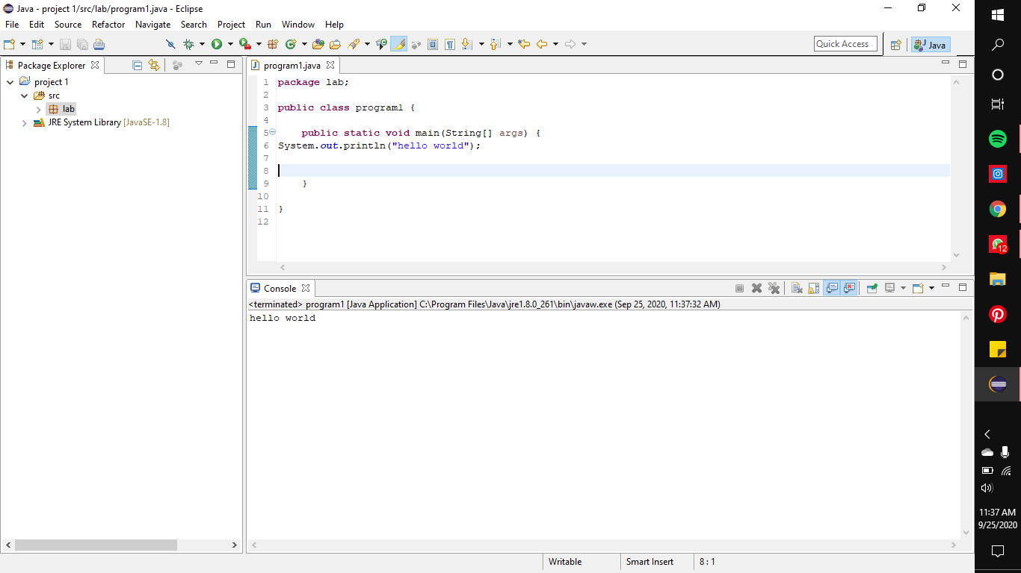

Program 2

**Write a Java program to find largest of three numbers using if construct**

**Code**:

package lab;

public class program1 {

public static void main(String[] args) {

int a=4;int b=5;int c=8;

if(a>b&&a>c)

System.out.println( "the largest is a");

else if(b>a&&b>c)

System.out.println( "the largest is b");

else if(c>a&&c>b)

System.out.println( "the largest is c");

}

}

**Output:**

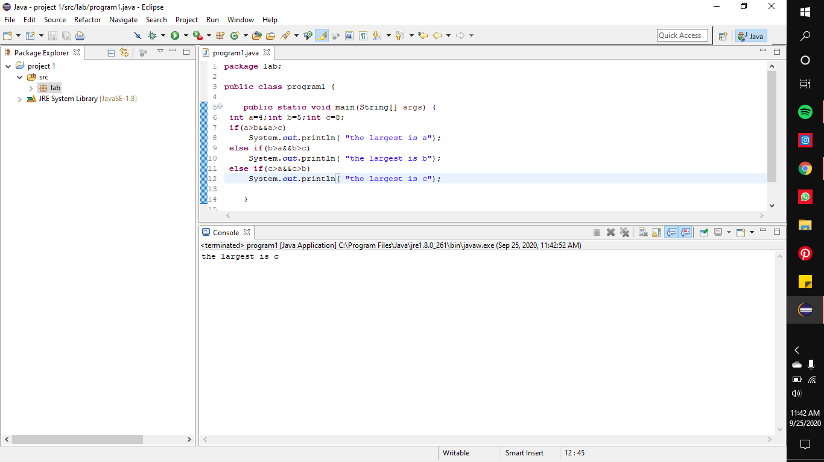

**Program 3:**

**Write a Java program to print the values from 1 to n by taking input from the user**

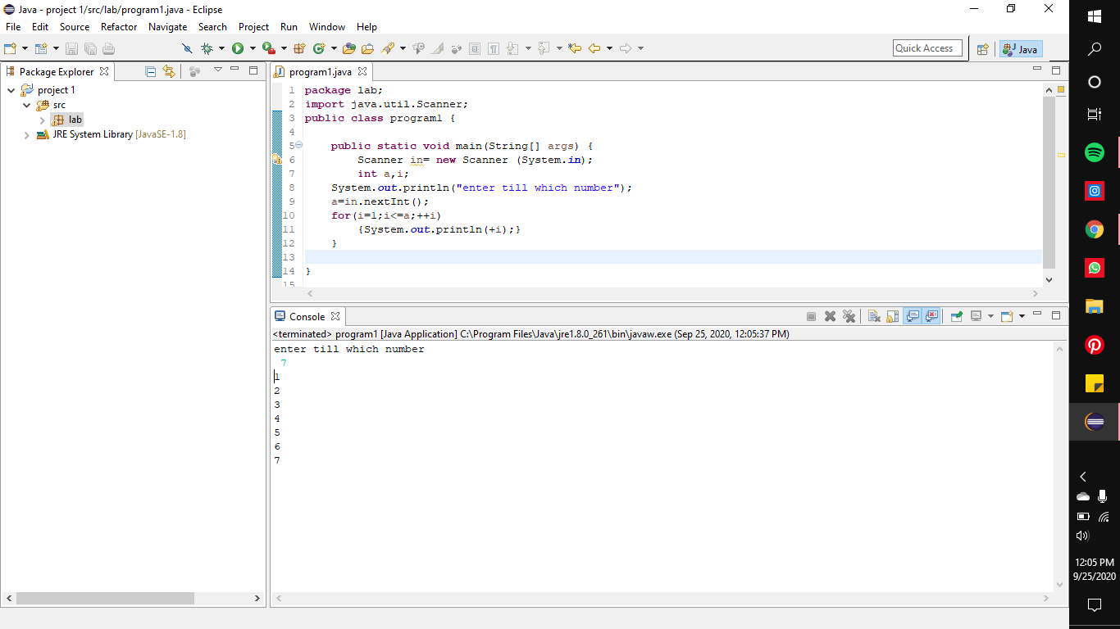

Code:

package lab;

import java.util.Scanner;

public class program1 {

public static void main(String[] args) {

Scanner in= new Scanner (System.in);

int a,i;

System.out.println("enter till which number");

a=in.nextInt();

for(i=1;i<=a;++i)

{System.out.println(+i);}

}

}

**Program 4**

Write a Java program to accept a number n from the user and print n rows of output as

given below if n=4.

1

2 3

4 5 6

7 8 9 10

**Code:**

package lab;

import java.util.Scanner;

public class program1 {

public static void main(String[] args) {

Scanner in= new Scanner (System.in);

int n,i,k=1,j;

System.out.println("enter till which number");

n=in.nextInt();

for(i=1;i<=n;++i)

{

{for(j=1;j<i+1;j++)

System.out.print(k++ +"");}

System.out.println();

}

}

}

**Output:**

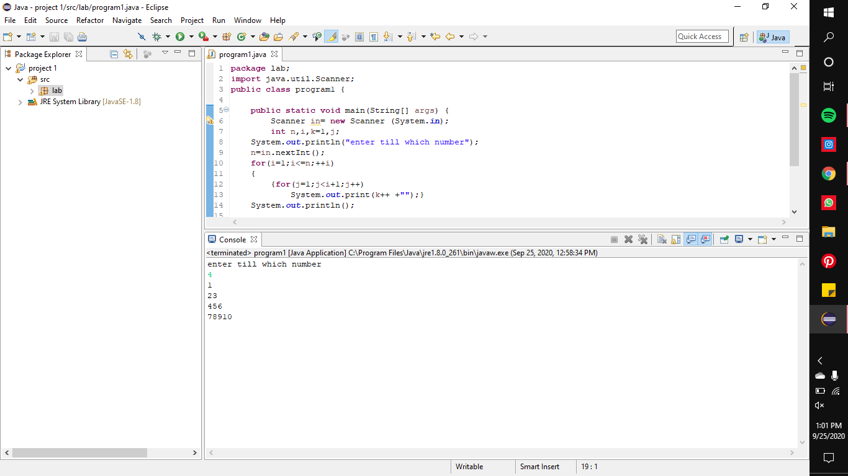

**Program 5**

**5. Write a Java program to accept the CIE marks (Out of 50) and SEE marks (Out of 100)**

**of a student and print his/her grade. Use if… elseif ladder**

**Code:**

package lab;

import java.util.Scanner;

public class program1 {

public static void main(String[] args) {

Scanner in= new Scanner (System.in);

int c,s,h,sum;

System.out.println("enter the cie out of 50");

c=in.nextInt();

System.out.println("enter the see out of 100");

s=in.nextInt();

h=s/2;

sum=h+c;

if((sum==100)&&(sum>=90))

System.out.println("grade-s");

else if(sum>=80)

System.out.println("grade-A");

else if(sum>=70)

System.out.println("grade-B");

else if(sum>=60)

System.out.println("grade-C");

else if(sum>=50)

System.out.println("grade-D");

else if(sum>=40)

System.out.println("grade-E");

else if(sum>=0)

System.out.println("grade-F");

}

}

**Output:**

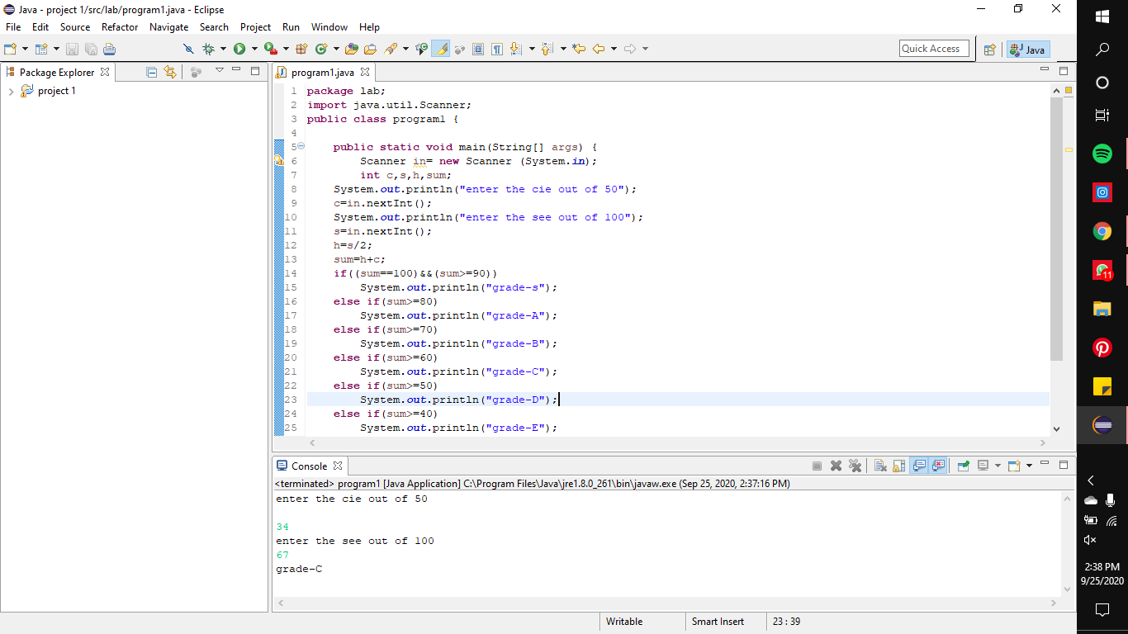

**Program 6:**

**Write a C/Java program to print the prime numbers between given two integers**

**(inclusive). Accept these two integers from the user.**

**Code:**

package lab;

import java.util.Scanner;

public class program1 {

public static void main(String[] args) {

Scanner in= new Scanner (System.in);

int c,s,count;

System.out.println("enter the first number");

c=in.nextInt();

System.out.println("enter the second number");

s=in.nextInt();

for(int k = c ; k <= s ; k++)

{

count = 0;

for(int j = 1 ; j <= k ; j++)

{

if(k % j == 0)

count = count+1;

}

if(count == 2)

System.out.println(k);

}

}

}

**Output:**

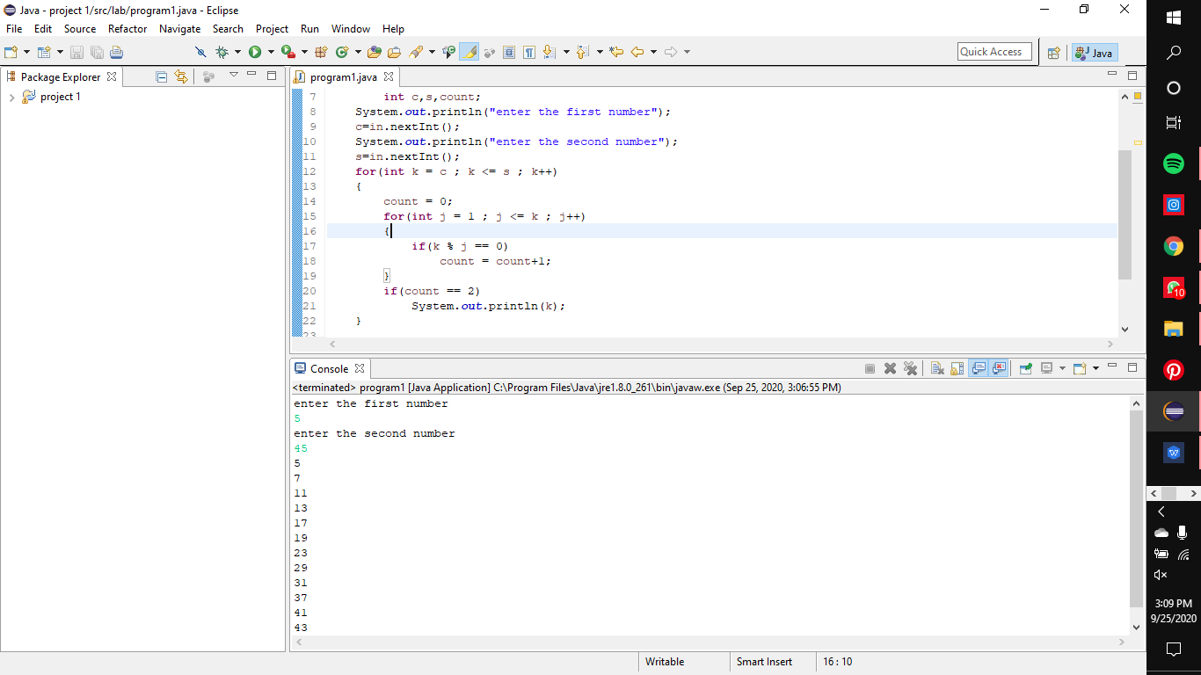

**Program 7:**

**Write a C program to count the number of students registered for three elective**

**courses. Accept the names of n students, their choice of the elective (Say, the electives**

**courses offered are Internet of Things, Advanced Java and J2EE and Advanced Data**

**Structures).**

**Include the following operations:**

**1. Accept say x from the user. Display the names of the students who have**

**opted for elective x**

**2. Count and display the total number of students present in each elective.**

**3. If count is less than 30, inform that the course will not be floated and ask**

**the students who have opted the course to reselect their electives from the**

**other two. Count and display the counts again.**

**4. Display the name of the students in each elective.**

**Output:**

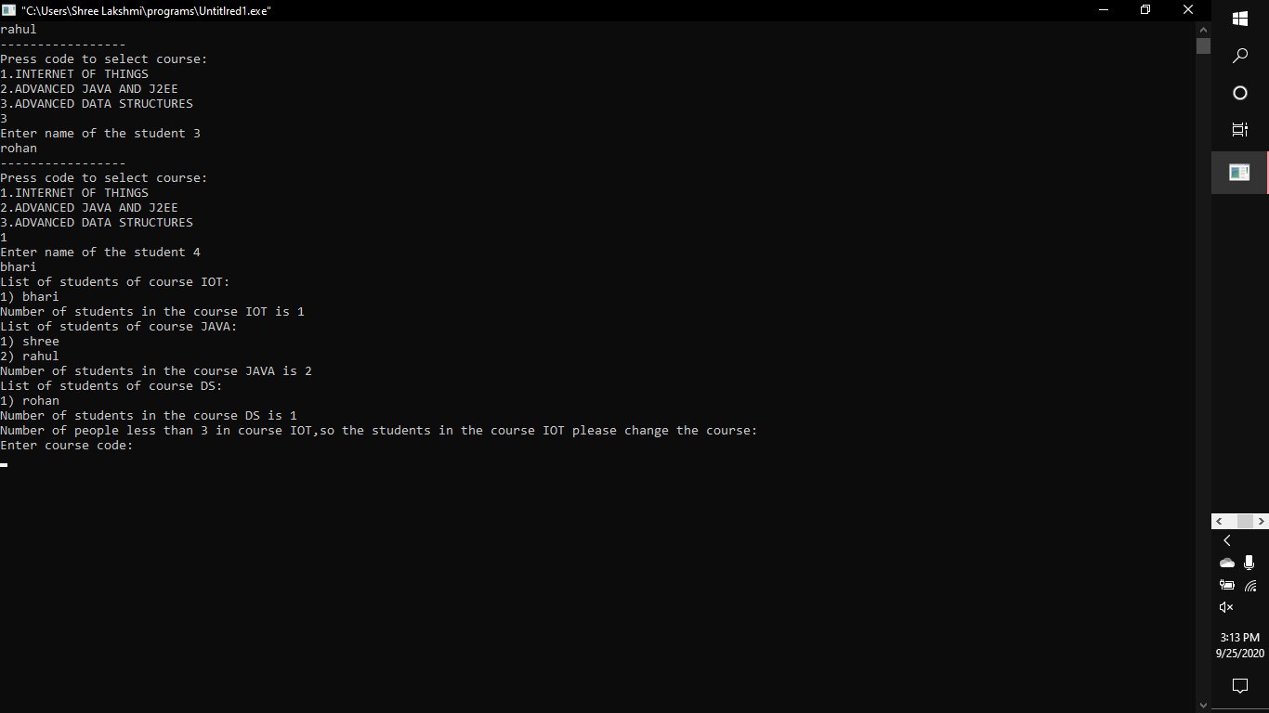

**Code:**

#include<stdio.h>

struct course

{

char name[20];

};

int main()

{

struct course s[3][100];

int n,i,j,c[3]={0,0,0},choice;

char cn[3][10]={"IOT","JAVA","DS"};

printf("Enter number of students:\n");

scanf("%d",&n);

printf("Enter student details:\n");

for(i=0;i<n;i++)

{

printf("-----------------\n");

printf("Press code to select course:\n1.INTERNET OF THINGS\n2.ADVANCED JAVA AND J2EE\n3.ADVANCED DATA STRUCTURES\n");

scanf("%d",&choice);

if(choice<0||choice>3)

{

printf("Invalid choice!\n");

continue;

}

printf("Enter name of the student %d\n",i+1);

scanf("%s",&s[choice-1][c[choice-1]].name);

c[choice-1]++;

}

disp:

for(i=0;i<3;i++)

{

if(c[i]>=0)

{

printf("List of students of course %s:\n",cn[i]);

for(j=0;j<c[i];j++)

{

printf("%d) %s \n",j+1,s[i][j].name);

}

printf("Number of students in the course %s is %d\n",cn[i],j);

}

}

for(i=0;i<3;i++)

{

if(c[i]<3&&c[i]!=-1)

{

printf("Number of people less than 3 in course %s,so the students in the course %s please change the course:\n",cn[i],cn[i]);

for(j=0;j<c[i];j++)

{

printf("Enter course code:\n");

scanf("%d",&choice);

if(choice==i+1){

printf("Enter other course!\n");

continue;

}

printf("Enter name:\n");

scanf("%s",&s[choice-1][c[choice-1]].name);

c[choice-1]++;

}

n=c[i];

c[i]=-1;

goto disp;

}

}

return 0;

}

**OBSERVATION BOOK:**

